Year 4 Homework
Set 27.02.2026
Subject | Task | Feedback | Due in w/c
Spellings | To ensure progress is made against the Year 3 and 4 spelling lists we are going to set a list of 76 words each week off the Year 3/4 statutory word list. Please can you work with your child to check they can read and spell the following words:  Station  Squeeze  Snooze beautiful wrist  Octopus worse awful  Mission  Magician  Quarter  Fifth | Marked in class and written on record cards | 04.03.2026
Maths | Fractions – Understanding the whole  My Maths (Login details are in homework books)  Complete sessions on ‘TT Rock Stars’. Help your class be the best in the year group. It takes everyone to complete 15 minutes a week! | Marked in class  Time given to practise multiplication tables | 04.03.2026
Reading | Regular reading at home is essential! Record your reading in your diary All children should have a book suitable for their level of reading. Please log your reading in your reading record at least 3 x per week. | Record all reading in your reading record
Literacy & handwriting practice | Use Vincent Van Gogh’s oil painting of the 15 sunflowers in a vase and start to develop descriptive sentences, using similes and adjectives.  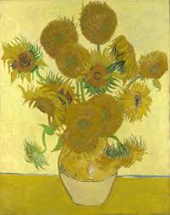 |  | 04.03.2026

