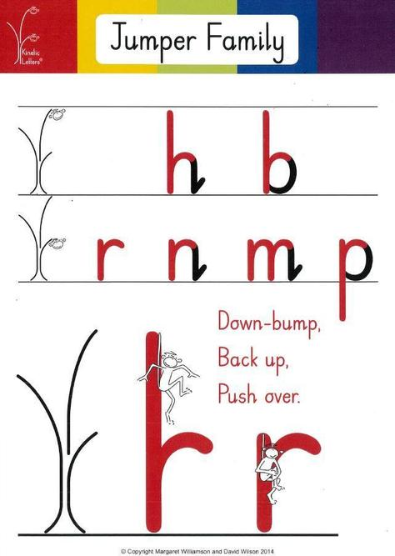
The Jumper Family Story
Bounce and Skip spend all day jumping down-bump from the branches of their tree!

Bounce jumps from the high branch and makes the letter trail for h and b.

Skip jumps from the low branch and makes the letter trail for r, n, m and p.

But...when Skip jumps down to make p, he gets a surprise! Instead of going bump, he falls on down into a pit that has a spider!

He jumps back up, pushing the cobwebs off to make the p letter trail!

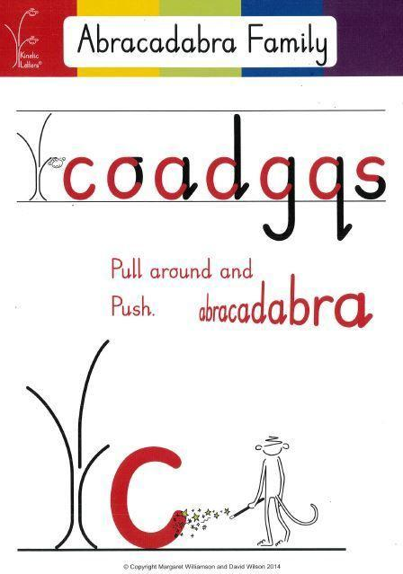
The Abracadabra Family Story
Scared Monkey Skip finds a magician who waves his wand and shouts 'Abracadabra' and makes lots of different letters appear under the lower branch of the tree.

The magician teaches Scared Monkey the magic trick. He shows him that for each of the letters, he can pull around to write c, shout 'Abracadabra' and then magic it into o, a, d, g, q, or s.

The Scared Monkey makes all the letters start from his branch.

The Window Cleaner Family Story
The Monkeys find themselves in a city standing by a shop window! They watch two window cleaners making marks as they dry the windows. The pull the squeegees down the windows and flick the water off at the bottom!
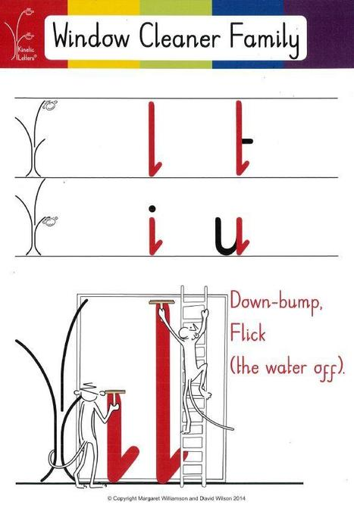
The window cleaners let the Brave Monkey climb the ladder, pull the squeegee down the window, bump the ground and flick the water off! This makes a l and the t.

Scared Monkey is nervous about climbing the ladder so he stays on the ground and makes an i and u.
The Fisher Family Story
One day there is a huge storm in the jungle which makes the river flood the spider's pit. Bounce the Brave Monkey and Skip the Scared Monkey sit in their tree and watch the fish swim around in the pit. Skip discovers that if he sits on his branch and dangles his tail in the water, he can pull his tail around to catch the fish!
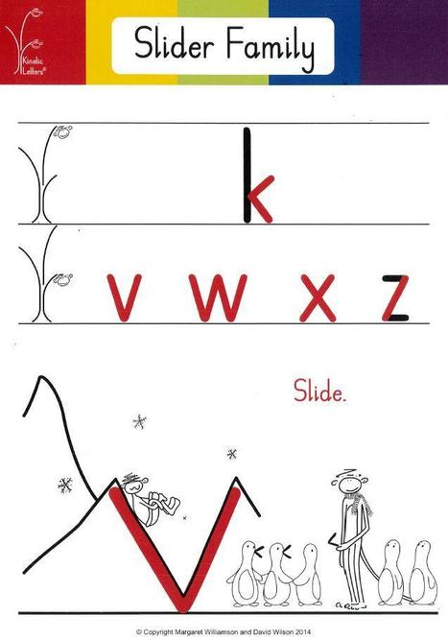
The Slider Family Story
One exciting day the magician waves his wand and takes Brave Monkey and Scared Monkey to see the snow!

Skip the Scared Monkey finds a snowy mountain slope and says 'I can slide down and slide up'. When he does this he can make the letters v, w, x and z.

Bounce the Brave Monkey goes to help the baby penguins who have lost their beaks! The penguins stand in line whilst the monkey fixes them back on and this makes the k!

The Special Squirter Story
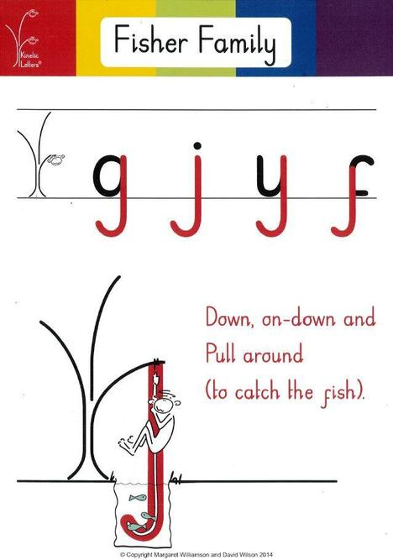
A big storm has flooded the pit under the monkeys' tree. The mole rats are upset, as this is where they live.

First Skip rescues the fish that have been washed into the pit. Next he asks the elephant to help by sucking the water up in his trunk and squirting it back into the river.

Skip helps by holding the trunk and squirting it under his branch, leaving a letter trail of water behind in the air!

Kinetic Letters also helps us to write our capital letters and our numbers.



